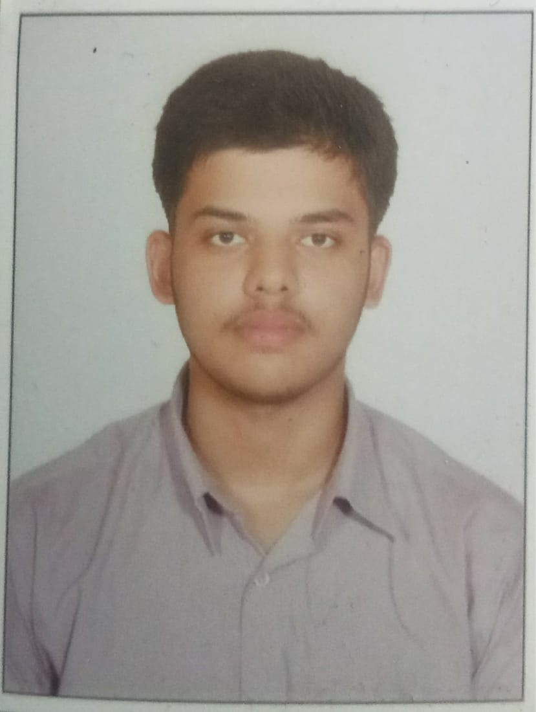

RAHUL GUPTA

Address: 1282/2 Rupa Mistri street Ludhiana, 141001
Mobile: +91 9803239930
Email: rg5353070@gmail.com

ACADEMIC QUALIFICATIONS

Qualification | Year | Institution | Grade
BCA(2nd Year) | 2021 - | PCTE GROUP OF INSTITUTES,LUDHIANA | 75%
Grade – XII | 2015 | St. Thomas Sr. Sec. School, Ludhiana | 95.2%
Grade – X | 2013 | St. Thomas Sr. Sec. School, Ludhiana | 88.8%

WORK EXPERIENCE

AIESEC in LUDHIANA
FEB 2022- SEPT 2022

- Worked as a Senior Business Manager responsible for partnership engagement as well as organization of various cultural and youth events
Projects
- Made a shopping cart website using Django Framework
- Created a StreamLit Web app In Python
- Created a Responsive Portfolio Website using Html and Css

TRAININGS & INTERNSHIPS

ANSH INFOTECH (LUDHIANA):
- Completed 4 weeks training of coding in Python

CERTIFICATIONS & RECOGNITIONS

- Successful completion of course “GIT and GITHUB” by Udemy in September 2022.
- WON 3rd Prize in a Business Idea Competition in PCTE GROUP OF INSTITUTES

INTEREST & HOBBIES

- Book Reading
- SPORTS
- CODING

